Practise Enterprise proposal

Thomas Van Nuffel

Description 1

MIDI interface 1

Features 2

General 2

Modes 2

Synth features 2

Hardware I/O 3

Input 3

Output 3

Other 3

How it’s gonna work 3

Extra features (if there is time left) 4

Photos 4

# Description

I want to make a synthesizer based on the XC888 which is compatible with MIDI. The synthesizer is a standalone, which only needs power to work. I will make an output stage with different kinds of jacks to connect to speakers etc. Also, a headphone connection will be applied.

## MIDI interface

This is not part of my project. I just want to make a synthesizer compatible with MIDI. But I do not make a full MIDI interface. Because of the simple reason, you have guys who build keyboards and guys who make MIDI interfaces. I make a keyboard compatible with MIDI, but I do not reinvent the MIDI. It exists and I use it. In my block diagram I added the MIDI interface but that is just because my keyboard works with MIDI I/O.

# Features

### General

I make a complete synthesizer. So, you can play a synthesizer. But my purpose is to make it simple for the user. So, with different modes the user can personalize for his own purpose.

The general features are:

* Synthesizer that is compatible with MIDI (to connect to pc or other devices)
* Making sound due incoming MIDI signals
* Output to speakers/ headphones
* Input going through an amplifier to the output.
* Leds are indicating which notes are on at the time.

### Modes

* Synth mode
  + All functions will work
  + MIDI still can be applied.
* MIDI mode
  + Every hardware for sound will be disabled (less power consumption)
* Adapter
  + In Synth mode: a power supply needs to be applied.
  + In MIDI mode: power supply or power from USB to PC

### Synth features

* Three basic output waveforms
  + Sinewave
  + Square wave
  + Triangle wave
* Effects
  + Envelope
    - This is a voltage controlled system with an attack and release
  + Low pass filter
  + High pass filter
* Output stage
  + Master
    - XLR
    - RCA
    - Jack
  + Headphone
* Mode to decide in which DDS the next sound will be generated.
  + One after the other, left to right, after that begin left.
  + Search for the first one which is not playing right now.

# Hardware I/O

## Input

* Maximal 96 keys

Sum is at absolute maximum 128

* Maximal 32 knobs
* Sliders (10)
* AUX in

## Output

* Audio master output (speakers)
  + RCA
  + XLR
  + Jack
* Headphone output
  + Jack
* Leds indicating which notes are pressed at the moment (midi or knobs)

## Other

* MIDI interface
* Power supply
  + Wall outlet
  + USB

# How it’s gonna work

You plug it in the wall outlet. The controller has an on/Off knob. Turn it on. Choose MIDI mode or Synth mode. A synthesizer speaks for itself how to use it. It has built-in speakers, so you do not need external speakers. Connect to a MIDI interface to use as a MIDI keyboard. You can play notes, you can use sliders. Dipswitches are indicating which region of the keyboard is enabled for controlling by knobs, the other parts are MIDI only. This will result in an interactive learn function.

# Extra features (if there is time left)

I am thinking of making some extra features with:

* Add more input
* Add more effects
* Optimize my synths compatibility with any DAW on my computer by MIDI. For example, that slider is assigned to this effect in any software.
* Give the leds on top of the keys another color (daresay one color for all the leds)
* Improving the “Learn to play” function.

# Photos

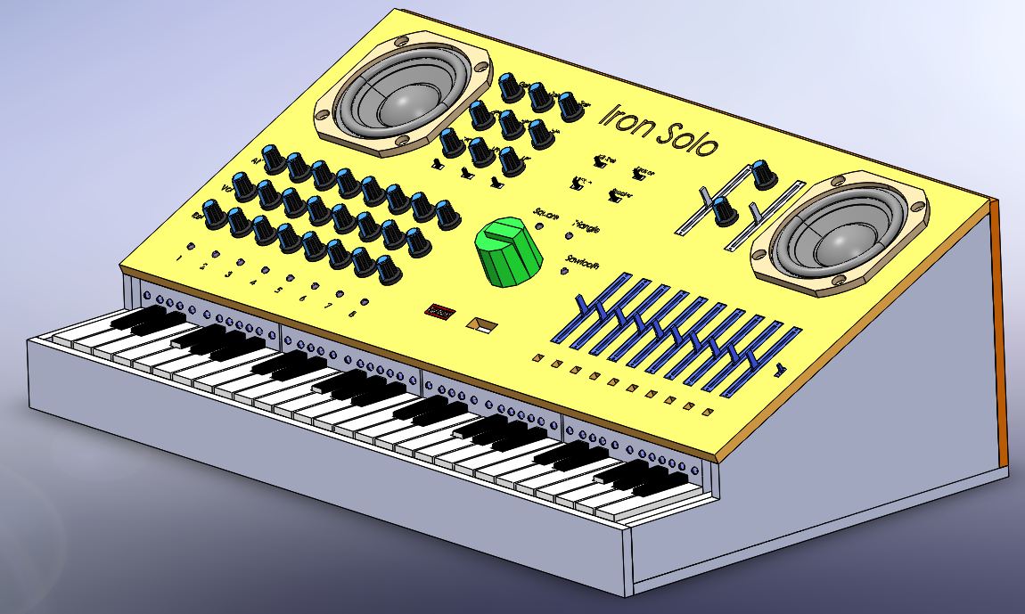

Master section

LPF and HPF

8 DDS modules with envelope and volume

MIDI sliders

Waveform selector

49 leds

Region selector

49 keys

